Smart Campus Energy Management System
Comprehensive Project Report
Group 001 - Kayode Babalola, Qianru Deng, Priyanka Sharma

Date: December 2024
Project Status: Planning Phase
Document Version: 1.0
Table of Contents
Executive Summary 5
Project Foundation & Strategic Alignment 6
1.1 Problem Analysis 6
1.2 Project Objectives 6
Project Scope & Boundaries 7
2.1 In-Scope Components 7
2.2 Out-of-Scope Elements 7
Risk Management Framework 8
3.1 Identified Risks & Mitigation Strategies 8
3.3 Key Assumptions 8
Technical Implementation Architecture 9
4.1 System Architecture Layers 9
4.2 Core Technical Features 10
Project Management Methodology 12
5.1 Agile Implementation Framework 12
5.1.1 Tools Integration Strategy 12
5.1.2 Aha! 12
5.1.3 Basecamp 13
5.1.4 GitHub 14
5.2 Phase-Based Implementation 15
5.3 Critical Path Analysis 16
Financial Analysis & ROI Projection 17
6.1 Investment Breakdown 17
6.2 Return on Investment Analysis 18
Deliverables & Success Metrics 19
7.1 Technical Deliverables 19
7.2 Analytical Deliverables 19
Implementation Timeline & Milestones 20
8.1 Key Milestones 20
8.2 Progress Tracking 20
Quality Assurance & Validation 21
9.1 Testing Strategy 21
9.2 Success Validation Metrics 21
Conclusion & Strategic Impact 22
10.1 Project Value Proposition 22
10.2 Long-term Strategic Alignment 22
10.3 Future Roadmap Considerations 22
Revision Summary 23
Appendix: AI Utilization Declaration 24
GPT Usage Acknowledgement 24
Specific Implementation Prompts 24

Executive Summary
Project Vision: The Smart Campus Energy Management System represents an innovative approach to addressing energy efficiency challenges in higher education institutions. This comprehensive solution integrates IoT technology, data analytics, and community engagement to transform traditional campus energy management into an intelligent, data-driven ecosystem.

Core Value Proposition: By implementing real-time monitoring, predictive analytics, and automated controls, the project aims to achieve a 10% reduction in energy consumption within one year while fostering sustainable practices across the campus community.

Project Foundation & Strategic Alignment

1.1 Problem Analysis
Higher education campuses face significant energy management challenges:
- Inefficient Consumption Patterns: Lack of real-time visibility into energy usage
- Limited Engagement: Insufficient mechanisms to involve students and staff in sustainability efforts
- Reactive Approach: Traditional systems lack predictive capabilities for proactive management
- Data Silos: Fragmented energy data across different campus buildings and systems

1.2 Project Objectives
- Quantitative Goal: 10% reduction in overall energy consumption within 12 months
- Monitoring Capability: Real-time energy tracking through IoT sensor deployment
- Community Engagement: Active participation of students, faculty, and staff in sustainability initiatives
- Data-Driven Decisions: Monthly usage tracking and actionable sustainability reporting

Project Scope & Boundaries

2.1 In-Scope Components
Component | Description | Deliverables
Energy Auditing | Comprehensive assessment across all campus buildings | Energy audit report, consumption baselines
Sensor Deployment | Installation of IoT sensors for real-time monitoring | 150+ sensors, calibration reports
Dashboard Development | Real-time energy monitoring interface | Web dashboard, mobile application
Educational Campaigns | Sustainability awareness programs | Workshop materials, engagement tracking
Data Analysis | Consumption pattern analysis and reporting | Monthly sustainability reports, insights

2.2 Out-of-Scope Elements
- Major infrastructure renovations or new construction
- Renewable energy installations (solar, wind)
- External facility management
- Comprehensive online training module development

Risk Management Framework

3.1 Identified Risks & Mitigation Strategies
Risk Category | Specific Risks | Mitigation Approach
Technical | Hardware deployment delays, integration challenges | Phased rollout, vendor management, technical validation
Budgetary | Cost overruns, unexpected expenses | 5% contingency allocation, regular budget reviews
Timeline | Project delays, scheduling conflicts | Critical path monitoring, milestone tracking
Adoption | Low user engagement, resistance to change | Change management, training programs, stakeholder communication
Dependencies | Departmental coordination, resource availability | Regular stakeholder meetings, clear communication channels

3.3 Key Assumptions
- Active cooperation from all campus stakeholders
- Reliable technology performance throughout implementation
- Consistent user engagement with educational campaigns
- Stable campus operations during deployment phase

Technical Implementation Architecture

4.1 System Architecture Layers
Sensing Layer
- Smart meters for energy consumption monitoring
- Motion and temperature sensors for occupancy and environmental data
- 150+ IoT units deployed across campus infrastructure

Data Layer (Google Cloud Platform)
- Compute Engine for data processing
- Cloud Storage for raw data retention
- BigQuery for analytical processing and reporting

Analytics Engine
- Energy consumption forecasting models
- Anomaly detection algorithms for abnormal usage patterns
- Predictive maintenance scheduling

Control Integration
- Siemens Desigo CC building management system
- BACnet protocol for automated HVAC and lighting control
- Real-time adjustment capabilities based on analytics

User Interface
- Facility manager dashboard for operational control
- Mobile application for student and staff engagement
- Real-time visualization of campus-wide energy usage

4.2 Core Technical Features
Real-time Energy Monitoring
- Live consumption data from all connected sensors
- Building-level and room-level granularity
- Historical trend analysis

Predictive Modeling
- Demand optimization algorithms
- Seasonal and occupancy-based forecasting
- Peak load management

Automated Control Systems
- HVAC optimization based on occupancy and external conditions
- Lighting control integration
- Energy-saving mode activation during low-usage periods

Alert Management
- Real-time notifications for abnormal consumption
- Maintenance alerts for equipment issues
- Customizable threshold settings

Project Management Methodology

5.1 Agile Implementation Framework

5.1.1 Tools Integration Strategy
Aha! → Strategic Planning & Road mapping
↓
Basecamp → Task Management & Collaboration
↓
GitHub → Technical Development & Version Control
↓
Utensil → Analytical Processing & Data Visualization

5.1.2 Aha!
Working Link: https://kcp-technologies.aha.io/products/PROD/feature_cards
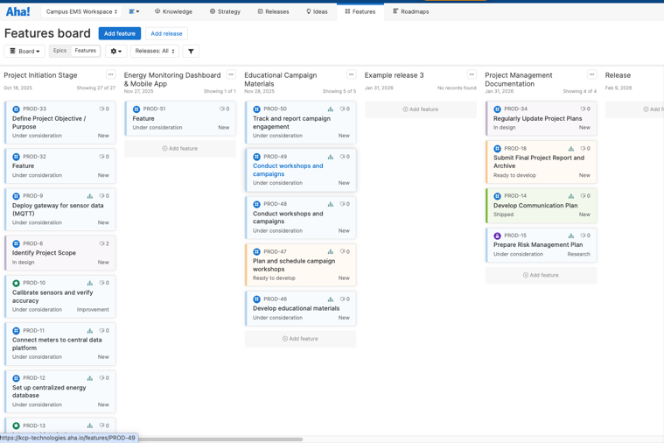
Aha! – Feature Board

Aha! – Solution Roadmap

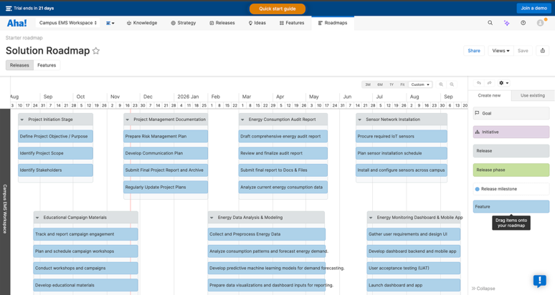
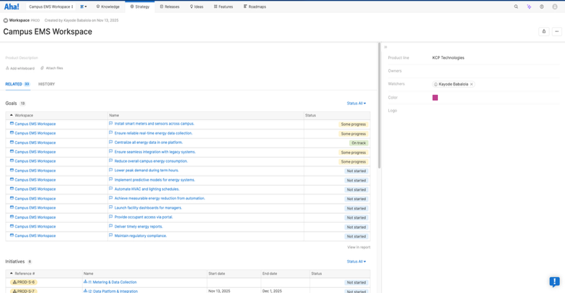
Aha! – Campus EMS Workspace

5.1.3 Basecamp
Working Link: https://3.basecamp.com/6076110/projects/44813742
Basecamp - Homepage
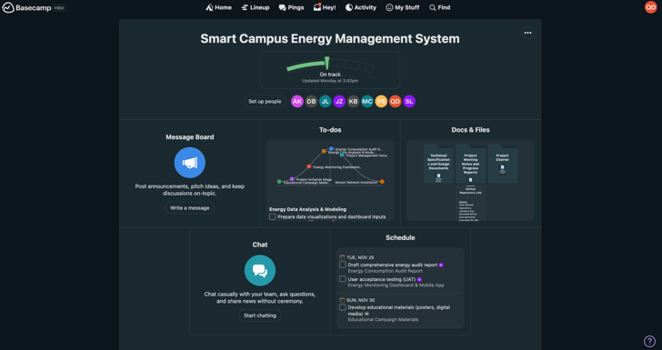
Basecamp – Schedule
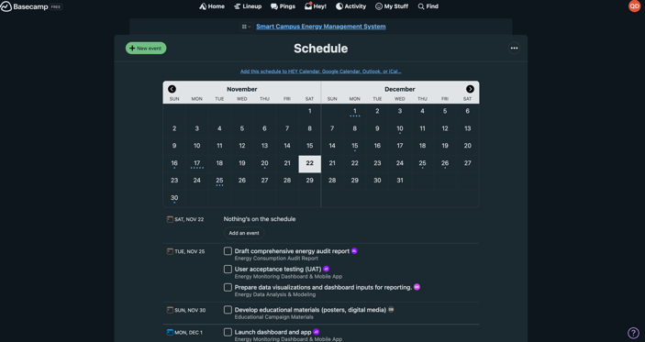
Basecamp – Docs & File
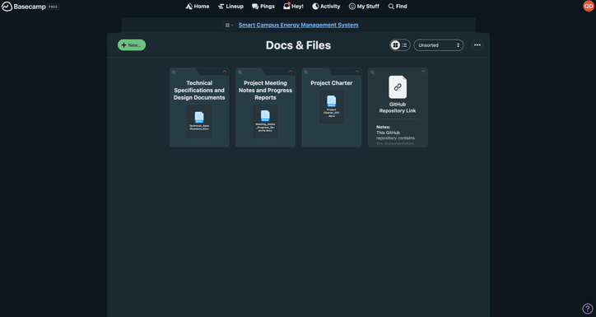
Basecamp – Todos
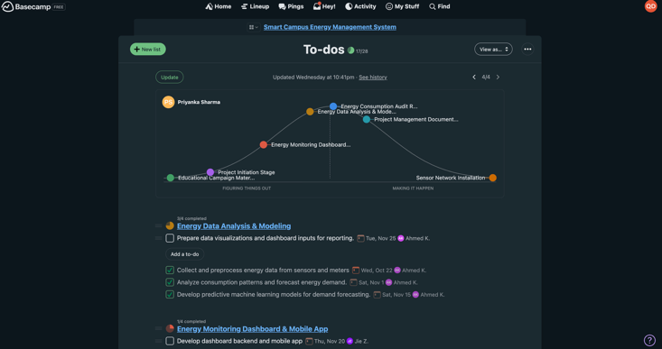

5.1.4 GitHub
Working Link: https://github.com/GangtieAda/Group001_project-Smart-Campus-Energy-Management-System
GitHub – Repository Homage
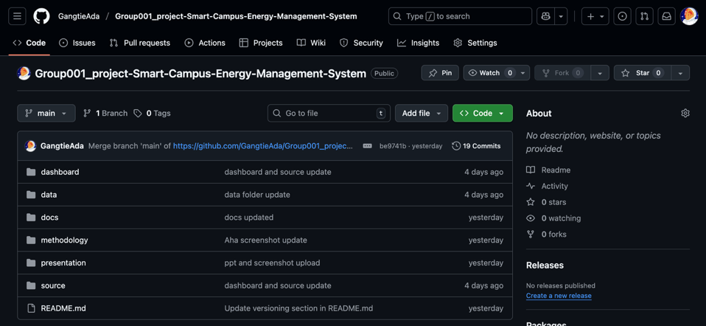
GitHub – Repository Structure
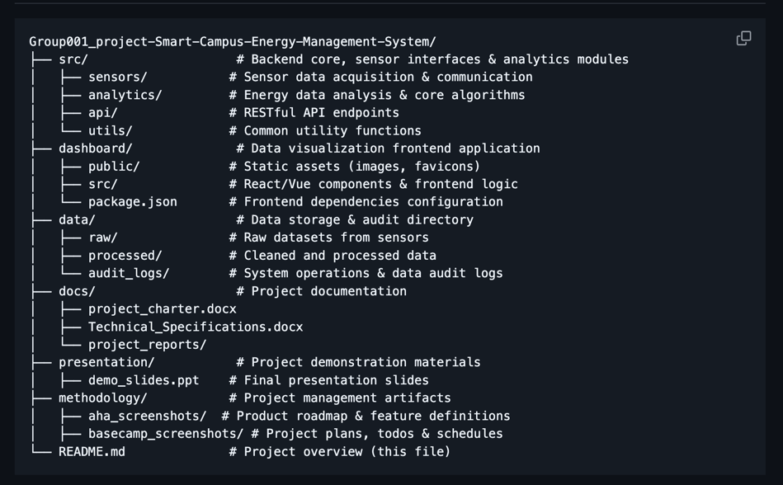

5.2 Phase-Based Implementation
Phase 1: Planning (September 2025)
- Project initiation and charter development
- Technical specifications finalization
- Stakeholder alignment and communication planning

Phase 2: Execution (October-November 2025)
- Sensor network installation (Oct 15 - Nov 15)
- Dashboard development (Oct 1 - Nov 30)
- Data analysis pipeline implementation
- Educational campaign material preparation

Phase 3: Transition (December 2025)
- System integration and testing
- User training and documentation
- Final project reporting and handover

5.3 Critical Path Analysis
Primary Critical Path: Dashboard Development → Energy Data Integration
Secondary Critical Path: Sensor Network Installation → Data Validation
Dependency Management: Regular synchronization between hardware and software teams

Financial Analysis & ROI Projection

6.1 Investment Breakdown
Labor Costs: $214,000
- Energy Systems Engineer: $44,000 (800 hours @ $55/hr)
- Electrical Contractors: $48,000 (1,200 hours @ $40/hr)
- Software Developers: $60,000 (1,000 hours @ $60/hr)
- Data Scientists: $36,000 (600 hours @ $60/hr)
- Project Manager: $26,000 (400 hours @ $65/hr)

Technology & Supplies: $87,500
- IoT Sensors: $37,500 (150 units @ $250/unit)
- Networking Equipment: $30,000 (20 units @ $1,500/unit)
- Cloud Services (GCP): $5,000 (1-year compute, storage, monitoring)
- Control Software Licenses: $15,000 (Siemens Desigo CC + BACnet)

Miscellaneous: $20,325
- Staff Training & Workshops: $5,000
- Contingency (5%): $15,325

Total Project Investment: $321,825

6.2 Return on Investment Analysis
Assumptions:
- Average campus energy cost: $1.2 million annually
- Target reduction: 10% ($120,000 savings)
- Additional operational efficiencies: $30,000 annually
- Reduced maintenance costs: $20,000 annually

Projected Annual Savings: $170,000
Simple Payback Period: 1.9 years
3-Year ROI: 158%

Deliverables & Success Metrics

7.1 Technical Deliverables
- Infrastructure: Deployed sensor network with installation reports
- Software: Real-time monitoring dashboard and mobile application
- Analytics: Forecasting models and data insight reports
- Documentation: Complete system documentation and user manuals

7.2 Analytical Deliverables
- Energy audit report with consumption baselines
- Monthly sustainability and consumption reports
- Predictive maintenance schedules
- Anomaly detection performance metrics

7.3 Educational Deliverables
- Workshop materials and presentation slides
- Engagement tracking reports
- Campaign effectiveness analysis
- Community participation metrics

Implementation Timeline & Milestones

8.1 Key Milestones
- September 23, 2025: Project Kickoff
- October 1, 2025: Dashboard Development Start
- October 15, 2025: Sensor Installation Commences
- November 15, 2025: Sensor Network Completion
- November 30, 2025: Dashboard Development Completion
- December 1, 2025: Project Deadline
- December 25-26, 2025: Ontario Holiday Period

8.2 Progress Tracking
- Hill Chart Methodology: Visual progress representation
- Weekly Status Updates: Team synchronization meetings
- Milestone Reviews: Formal assessment at key project phases
- Stakeholder Reporting: Monthly progress updates to campus leadership

Quality Assurance & Validation

9.1 Testing Strategy
- Unit Testing: Individual component validation
- Integration Testing: System-wide functionality verification
- User Acceptance Testing: Stakeholder validation of deliverables
- Performance Testing: System reliability under load conditions

9.2 Success Validation Metrics
- Energy consumption reduction (target: 10%)
- System uptime and reliability (target: 99.5%)
- User adoption rates (target: 80% of target users)
- Alert accuracy and response times (target: <15 minutes)

Conclusion & Strategic Impact

10.1 Project Value Proposition
- The Smart Campus Energy Management System delivers transformative benefits:
- Financial Impact: Significant cost savings through optimized energy consumption
- Operational Efficiency: Automated controls reducing manual intervention
- Sustainability Leadership: Positioning the institution as an environmental steward
- Educational Value: Practical sustainability learning platform for students

10.2 Long-term Strategic Alignment
This project establishes a foundation for continuous improvement in campus sustainability:
- Scalable architecture supporting future expansion
- Data-driven decision-making culture
- Community engagement in sustainability initiatives
- Alignment with institutional environmental goals

10.3 Future Roadmap Considerations
- Phase 2: Renewable energy integration
- Phase 3: Advanced predictive analytics expansion
- Phase 4: Campus-wide sustainability certification pursuit

Revision Summary
Initial Submission:
Initial project charter submitted, including scope, schedule, and cost estimates.

Updated Submission:
Refined cost estimates (cloud + Siemens software).

Final Revision:
Added Solution Roadmap, Basecamp milestones, GitHub repo structure, and clarified assumptions. Ready for final review.

Appendix: AI Utilization Declaration

GPT Usage Acknowledgement
"This comprehensive project report was developed with the assistance of ChatGPT to enhance clarity, organization, and professional presentation. Specific applications included:

- Content Structuring: Organizing project components into a coherent narrative flow
- Technical Explanation Enhancement: Clarifying complex architectural concepts
- Professional Formatting: Ensuring consistent and professional document standards
- Stakeholder Communication: Refining messaging for different audience types

All AI-assisted content has been thoroughly reviewed, validated, and customized to accurately represent our project vision and implementation strategy. The project team maintains full responsibility for the accuracy, completeness, and professional quality of this deliverable."

Specific Implementation Prompts
- "Create a comprehensive project report for a smart campus energy management system"
- "Develop risk management framework for IoT implementation in educational settings"
- "Structure financial analysis for campus energy efficiency project"
- "Outline technical architecture for real-time energy monitoring system"

